Functional Requirements of Thesauri Management

More from VocBench

Use Case:

1. Import a thesaurus (text format, xml, …)
2. Export a thesaurus (RDF, JSON, …) with/without metadata
3. Manage an entry (add/modify/delete), relationship –
4. Manage user account/permission
5. Expose as Linked Data /support LDP
6. Versioning control
7. Visualization support?
8. Generate metadata for each thesaurus including some statistics – Linked Data/support LDP
9. Run as a standalone thesaurus; can be connected to a repository?
10. Published/Private?
11. Search
12. Sparql endpoint

VocBench:

the objective of enabling a quicker, dataset independent, setup and providing a collaborative platform for the management of SKOS-XL thesauri.

* Schemes module to enhance multi scheme management and develop several skos:ConceptSchemes for the same dataset, providing different views on the data.
* Statistics module to provide statistical information about the loaded data.
* Export module to export the whole or a part of the content of a project.
* Load data module to load bulk data serialized in some RDF serialization standard.
* SPARQL module to query/update content directly through the SPARQL query language for RDF.
* Ontology Import Management to owl:import ontologies to be used as property
* vocabularies for the modelled thesauri.
* New tabs under the concept view for covering extensively the SKOS-XL standard (Note, Notations, Scheme).
* RSS feeds for all editing actions.

Registration & Login

1. Login / forgot your username or password?
2. Create an account

# Registration

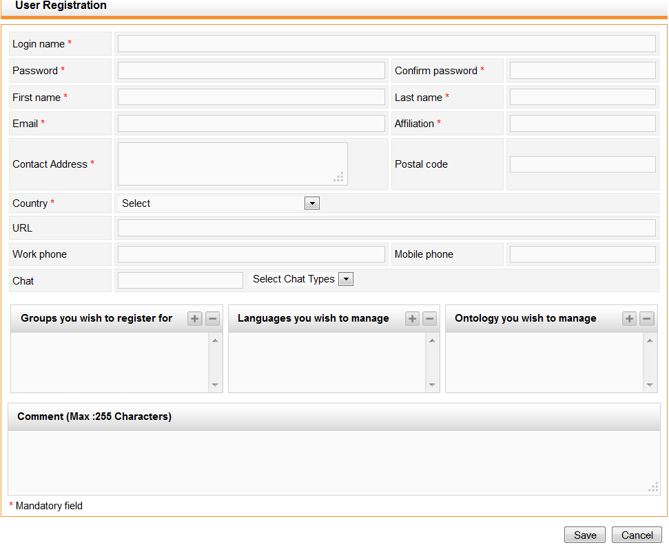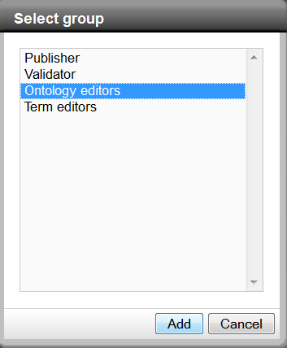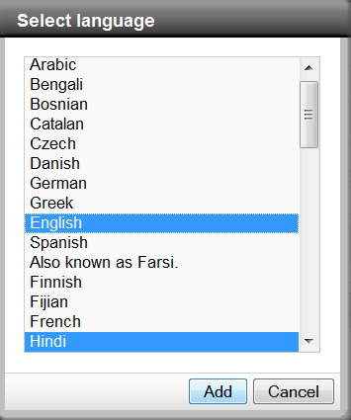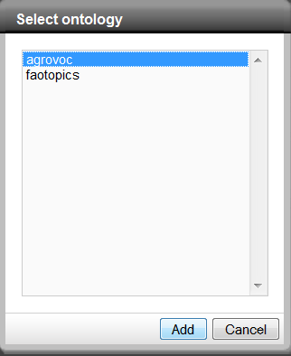

Registration confirmation.

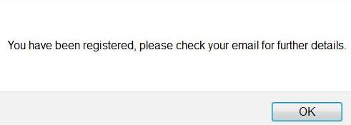

# Login

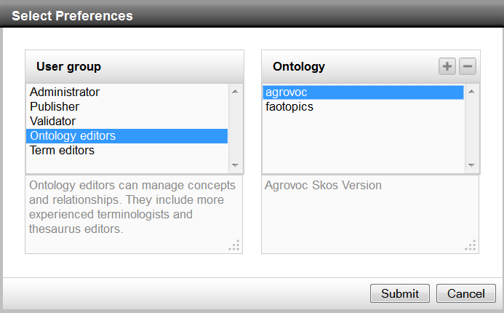

Login: Add ontology (project)

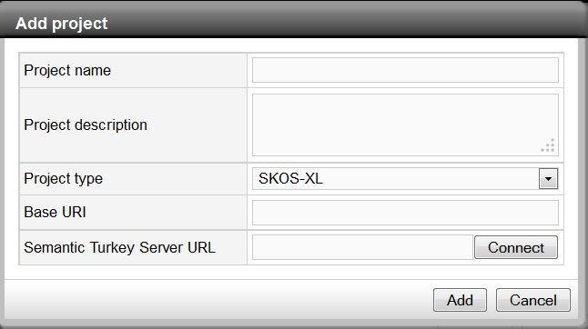

Main User Interface

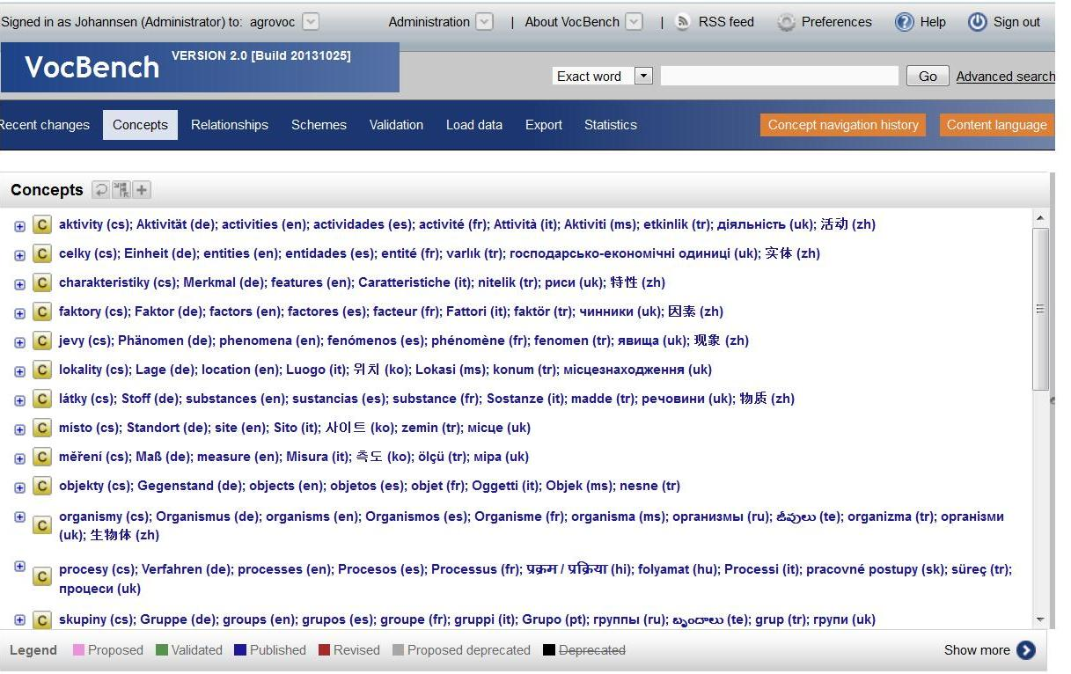

User name; User role; Dataset (default - current)?

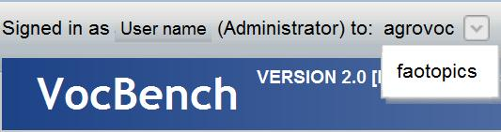

Administration:

1. User management: (Admin/publisher)

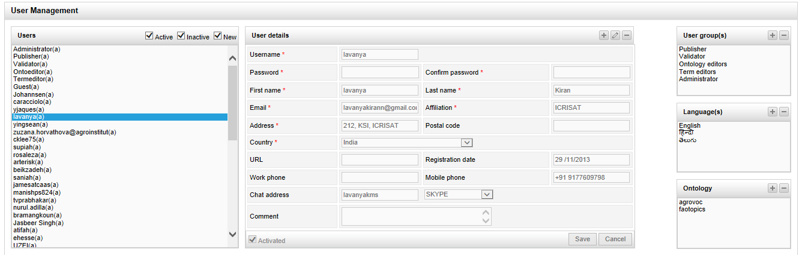

1. Group management: (Admin/publisher)

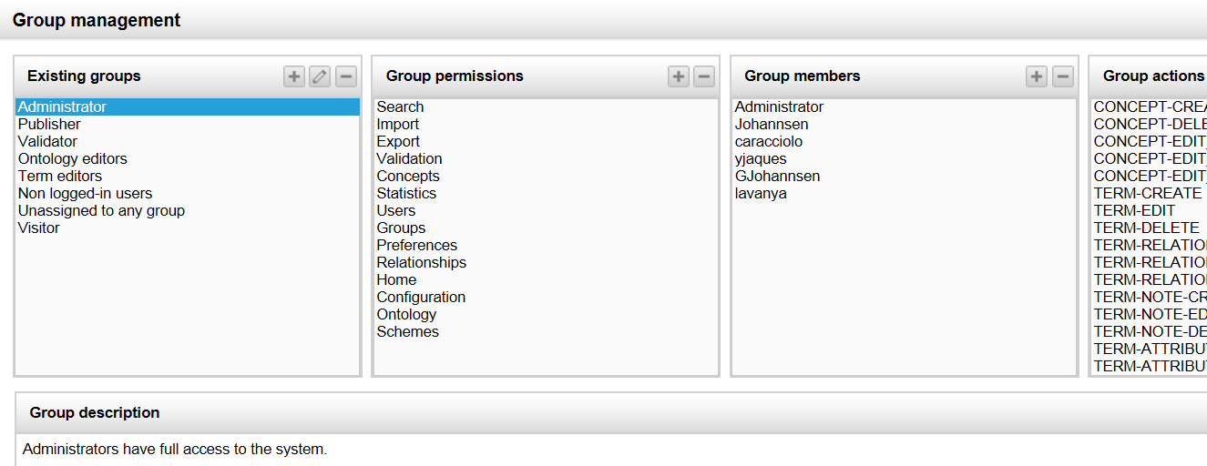

1. Ontology management: (Admin only)

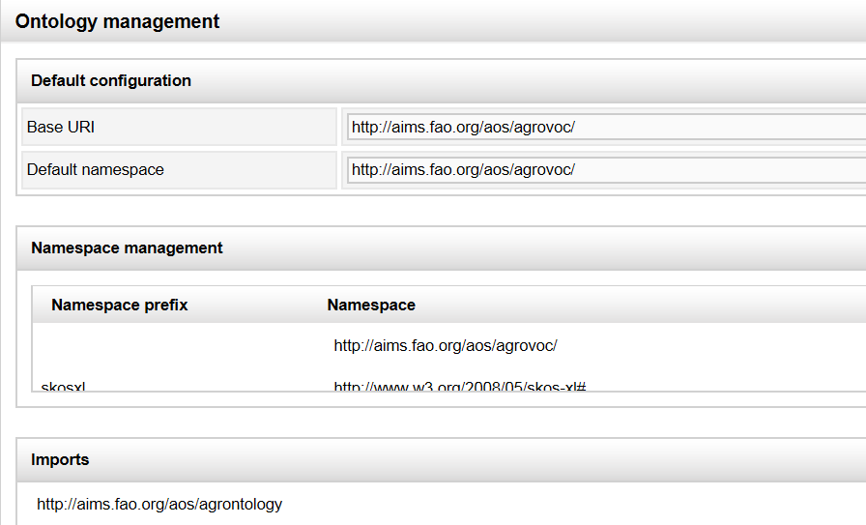

1. Configuration (Admin only)

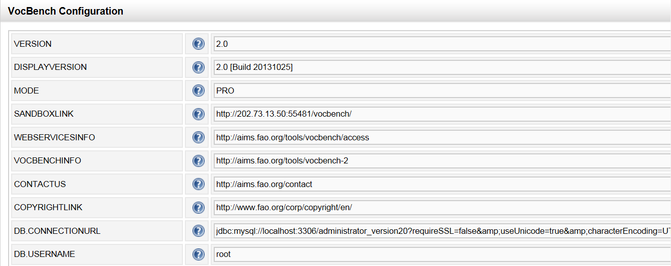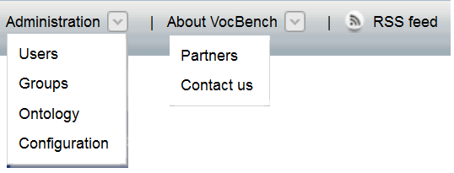

**About VocBeach** - general information

**RSS Feed** ??

**Perferences** - manage your own account information, user interface, password, language

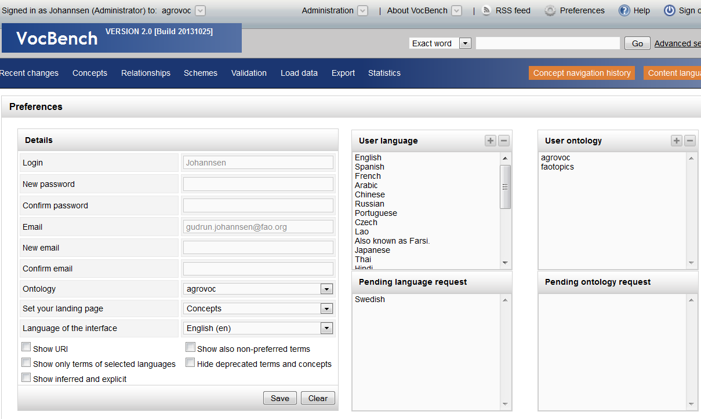

**Help -** Links to help

**Sign out -**  sign out

**Search**

**1. Default basic search**

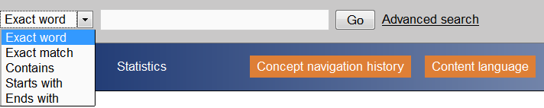

Search result

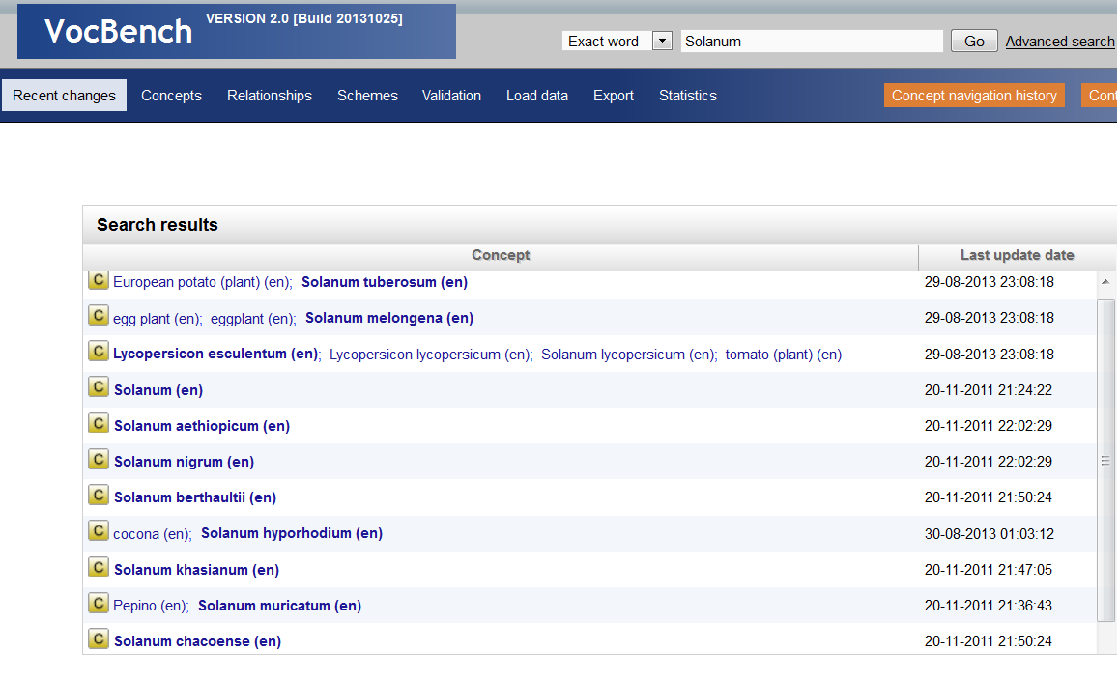

1. Advanced Search

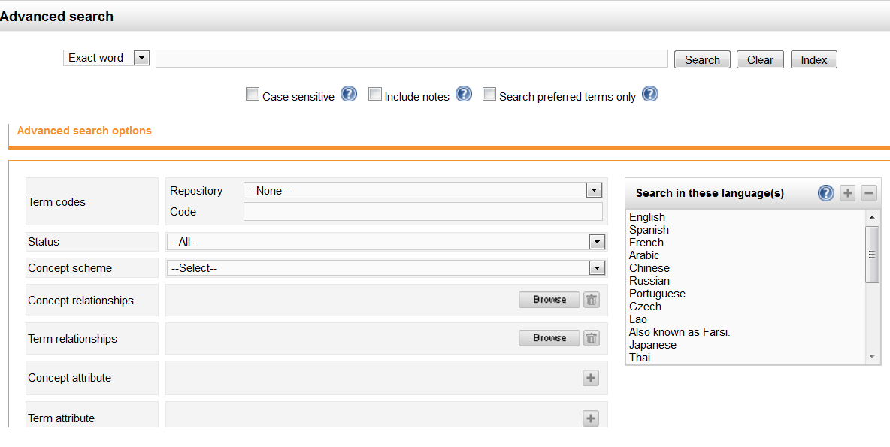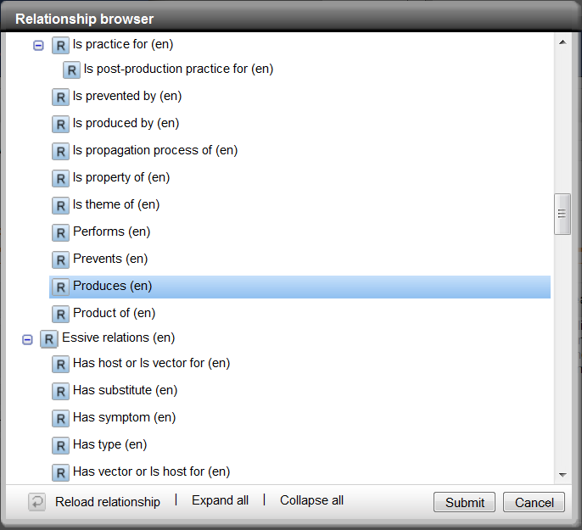

Result

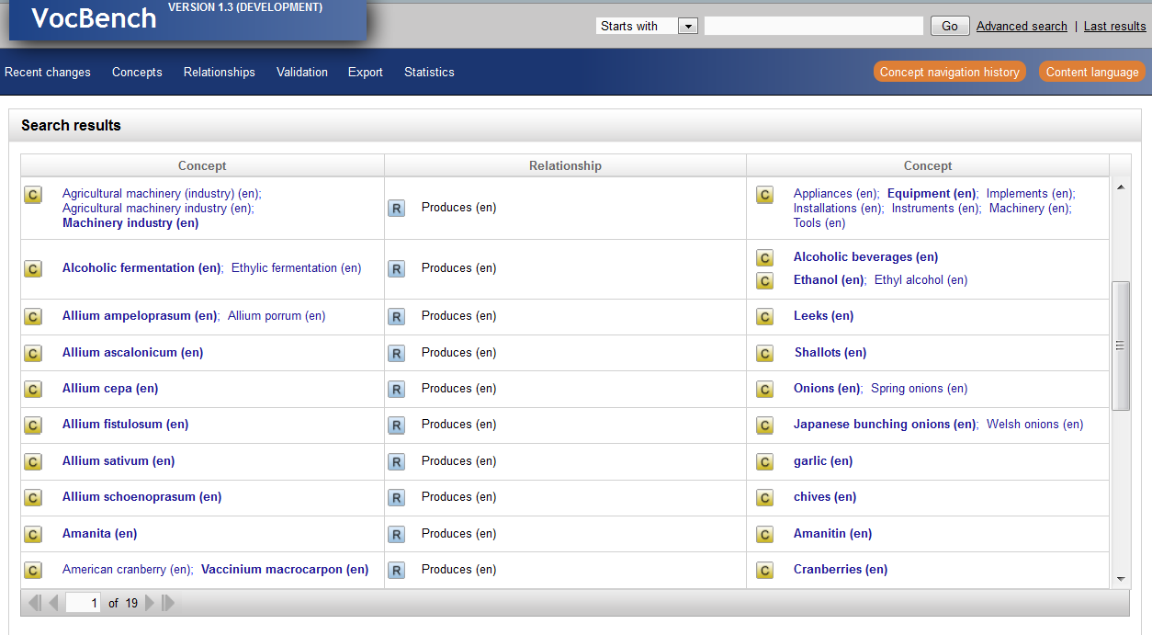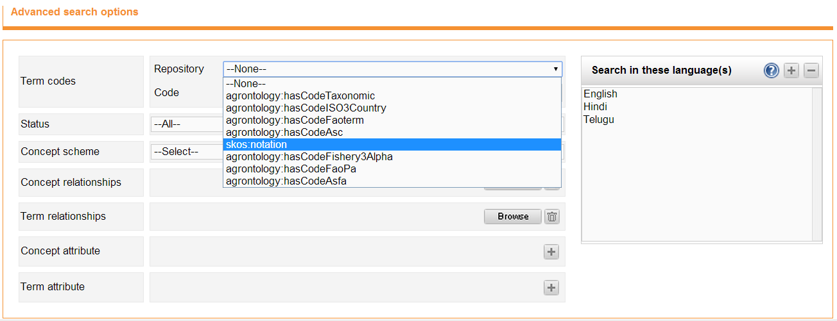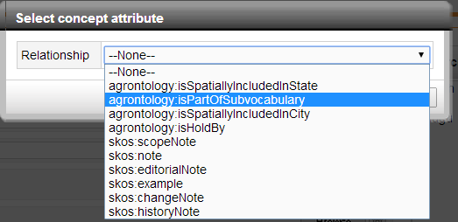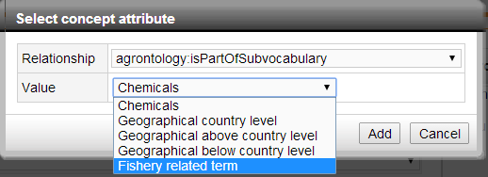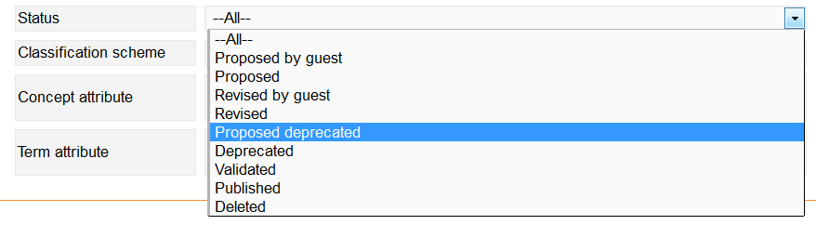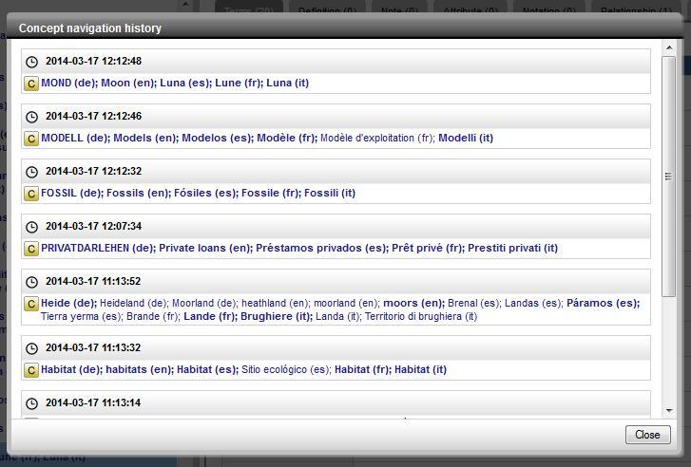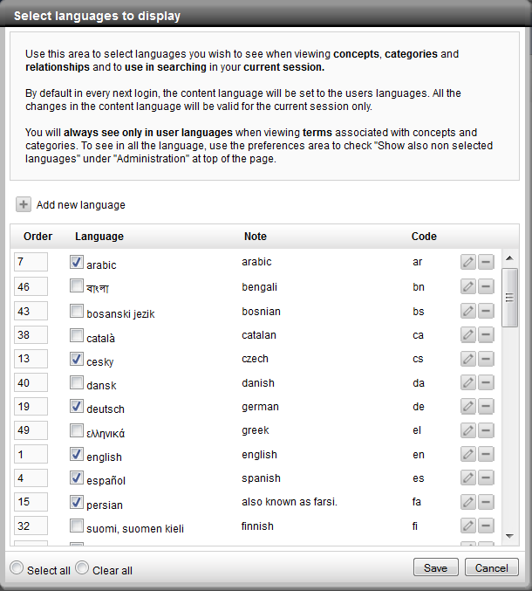

**Content management:**

**Recent changes -** List recent changes to terms, concepts, users, ...

**Concepts:** left concept hierarchy, right details

Add,

Edit

Delete concetps, terms, relationships

**Properties (Admin/publisher)**

**Schemes (Admin)**

**Validation (Admin, publisher, validator)**

**Load Data (Admin)**

**Export**

**Statistics (Admin, Publisher, validator, ontology editor)**

**SPARQL (admin)**



Concept navigation history - All roles

Content language - All roles



**User roles**

Possible roles in the workflow are:

1. Term Editor

2. Ontology Editor

3. Validator

4. Publisher

5. Administrator

7.2.1 Term Editors

Term Editors are the users of VB with the most restricted editing rights. They are usually

terminologists by background.

Term Editors may access the following modules:

• Recent changes

• Concepts

• Export

In the Concepts module, Term Editors may perform the following actions:VB v2.1 User Manual

Page 48 of 102

• Add, edit and delete terms.

• Add, edit and delete relations between terms and any other piece of information for

terms.

• Add, edit and delete concepts.

• Add, edit and delete relations between concepts and any other piece of information for

concepts.

All actions performed by a Term Editor get either the status Revised or Proposed, depending of

the action undertaken, and need to be approved by a Validator.

7.2.2 Ontology Editors

Ontology Editors are more experienced terminologists and thesaurus editors and have all the

rights of Term Editors.

Ontology Editors have access to the following VB modules:

• Recent changes

• Concepts

• Export

• Statistics

In the Concepts module, Ontology Editors may perform the following:

• Add, edit and delete terms.

• Add, edit and delete relations between terms and any other piece of information for

terms.

• Add, edit, delete concepts.

• Add, edit, and delete relations between concepts and any other piece of information

for concepts.

All actions performed by an Ontology Editor get either the status Revised or Proposed, depending

of the action undertaken, and need to be approved by a Validator.VB v2.1 User Manual

Page 49 of 102

7.2.3 Validators

Validators are experts that can check and validate the work done by Term Editors and Ontology

Editors. Validators have all the rights of Term Editors and Ontology Editors.

Validators may access the following modules of VB:

• Recent changes

• Concepts

• Validation

• Export

• Statistics

In the Concepts module, Validators may perform all actions also allowed to Term and Ontology

Editors.

In the Validation module, Validators may accept or reject any action that has been proposed by

Term and Ontology Editors. Those items then get the status Validated or Deprecated (in the case

of the status Proposed deprecated).

7.2.4 Publishers

Publishers are those who have the total control over the concept scheme and are responsible for

publishing the validated entities.

Publishers have all the rights of Term Editors, Ontology Editors and Validators. The following

describes publishers' roles and privileges.

Publishers have access to the following modules:

• Recent changes

• Concepts

• Properties

• ValidationVB v2.1 User Manual

• Export

• Statistics

Page 50 of 102

In the Concepts module, Publishers may perform all actions allowed to Term Editors, Ontology

Editors and Validators, plus the following ones: Move, link and unlink concepts.

In the Validation module, they may validate changes applied by Editors, and confirm changes applied by

Validators. They ultimately change the status to Published.

They can still reject validated entries and thus remove them again from the model (in case of new

proposals) or reset them to their previous status (in the case of Proposed Deprecated).

In the Properties module, they may edit or create new properties.

Finally, Publishers have access to the link Administration in the menu area, from where the Users

and Groups menus are available.

7.2.5 Administrators

Administrators have access to all VB modules and have overall rights!

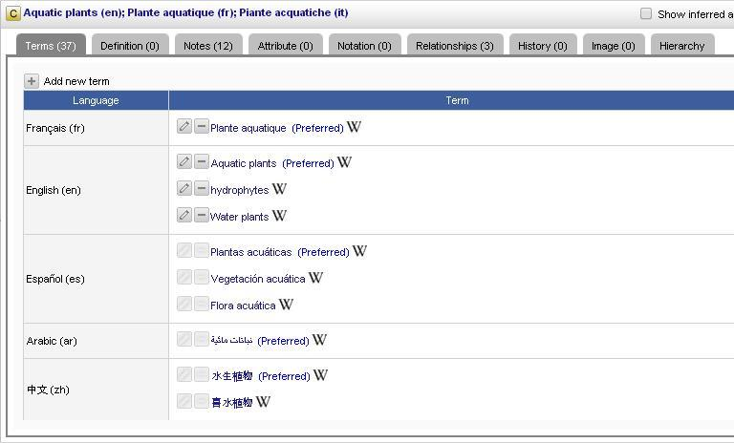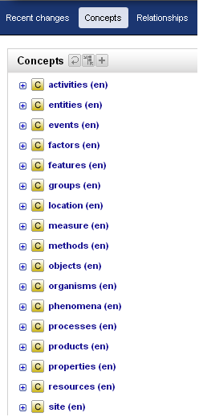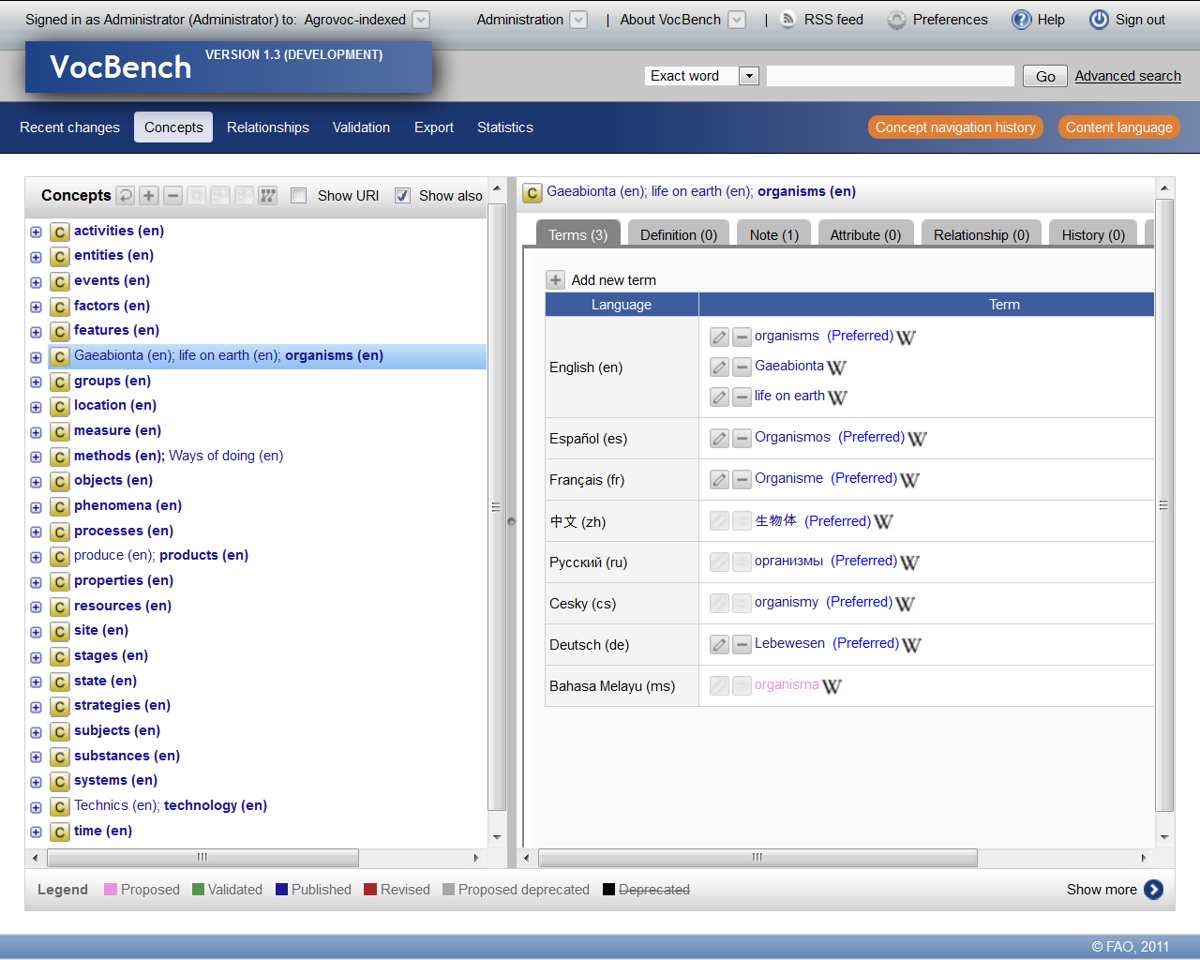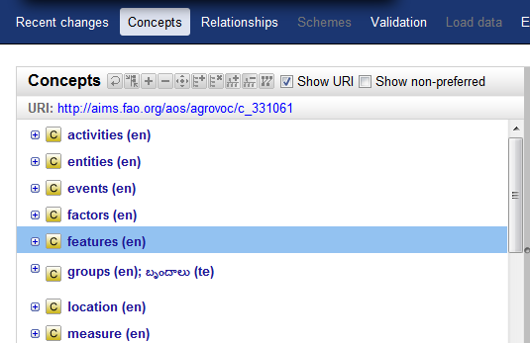

• Reload concept

Refreshes the screen and reloads the selected concept or the entire hierarchy if no concept

is selected.

• Collapse all

This tab collapses the concept or all the concepts when its hierarchy is being expanded.

• Add new concept

To add a new concept to the hierarchy.

• Delete concept

To delete the selected concept.

• Move concept

To move the selected concept.

• Link concept

To link the selected concept to a new child concept.VB v2.1 User Manual

Page 59 of 102

• Unlink concept

To unlink the selected concept from the hierarchy.

• Add concept to scheme

VB supports the management of multiple schemes 8 inside the same project 9 . This

functionality allows you to make the concept also belong to another scheme within the

same project.

• Remove concept from scheme

The opposite of the above, allows you to detach a concept from a given scheme.

• View graph

Opens a new window or tab with a graphical representation of the selected concept and its

relations with other concepts (Figure 52).

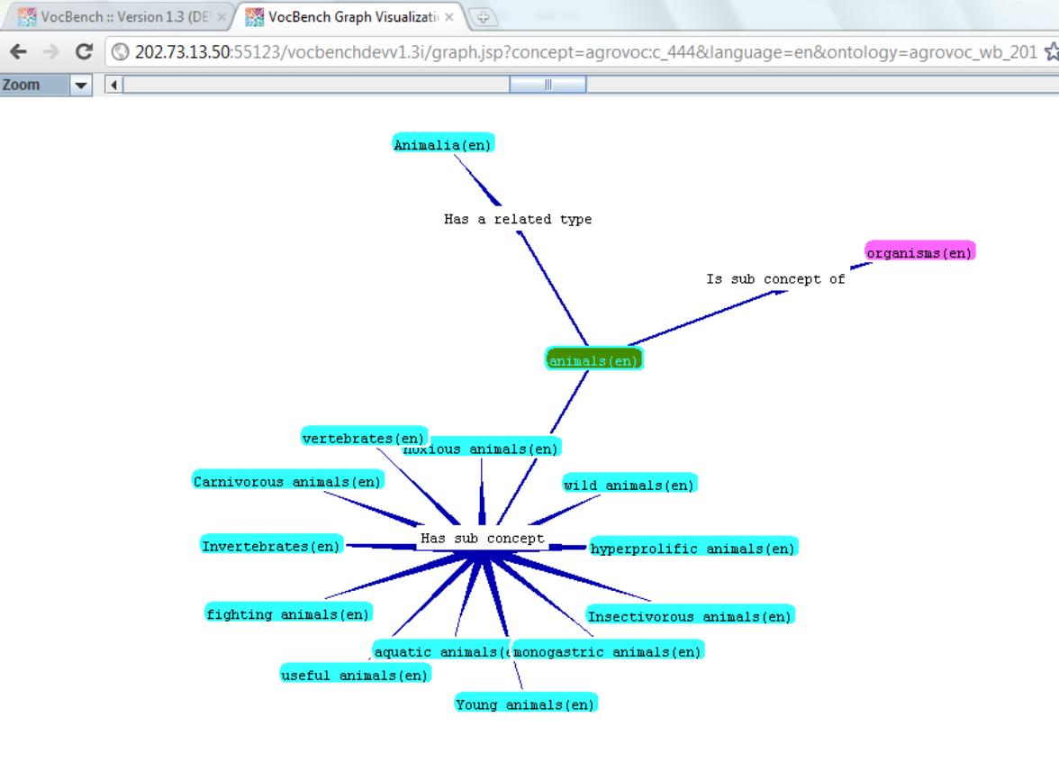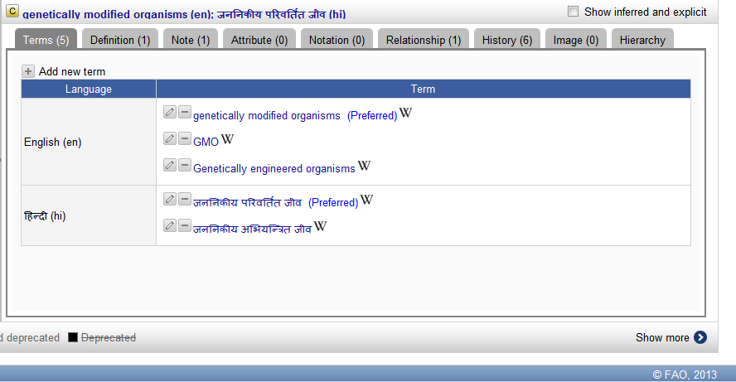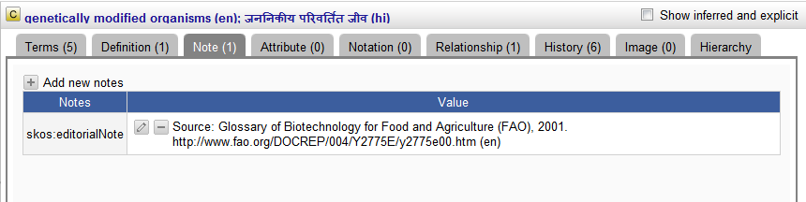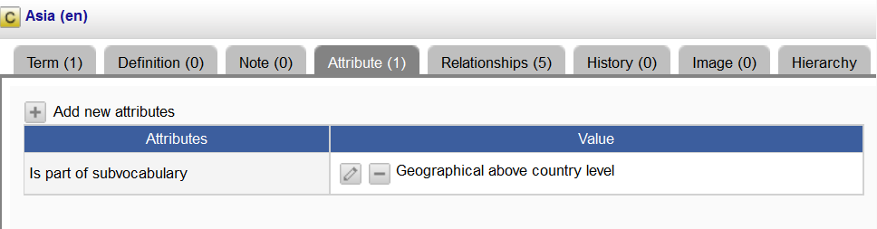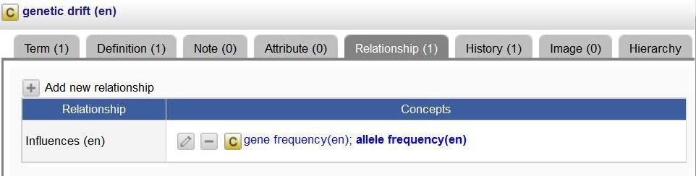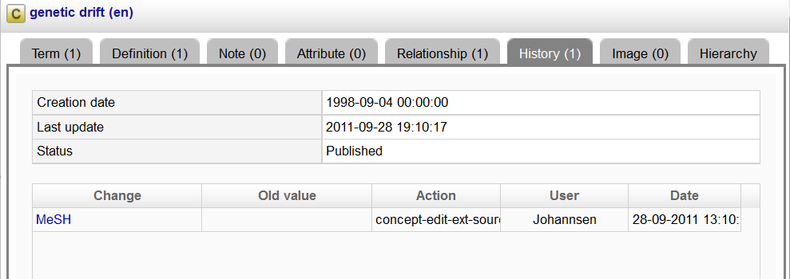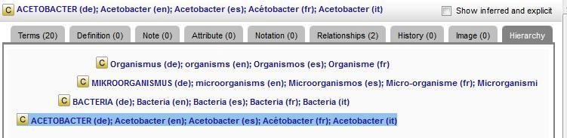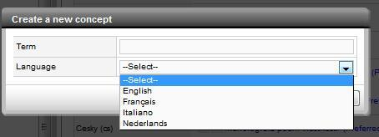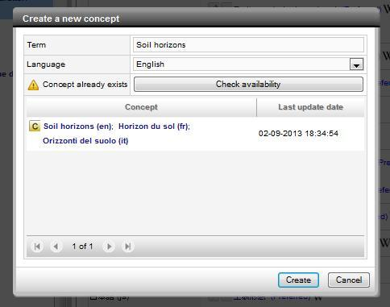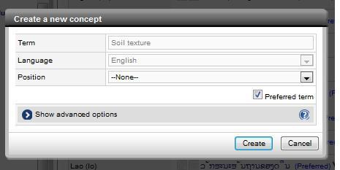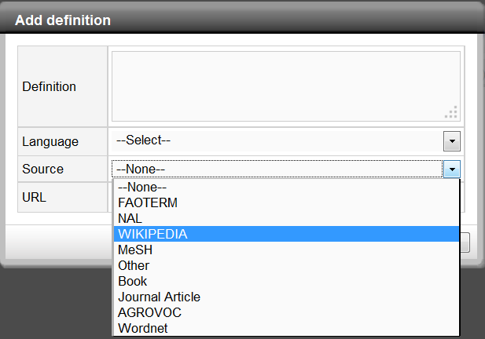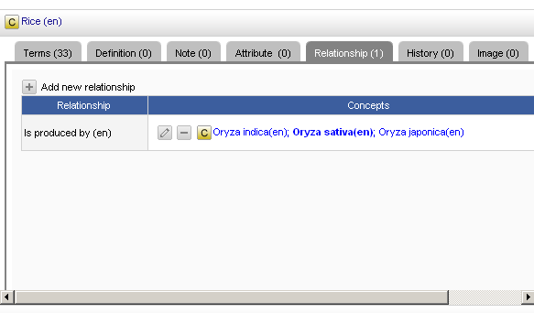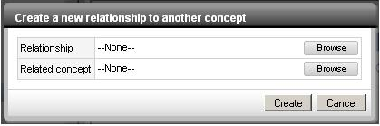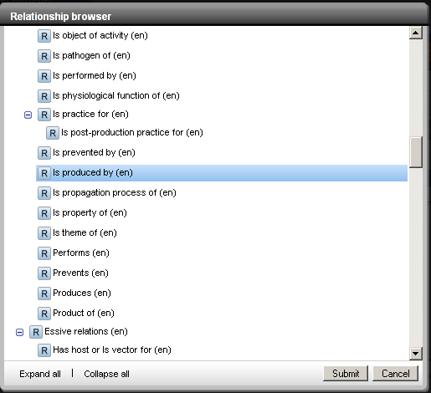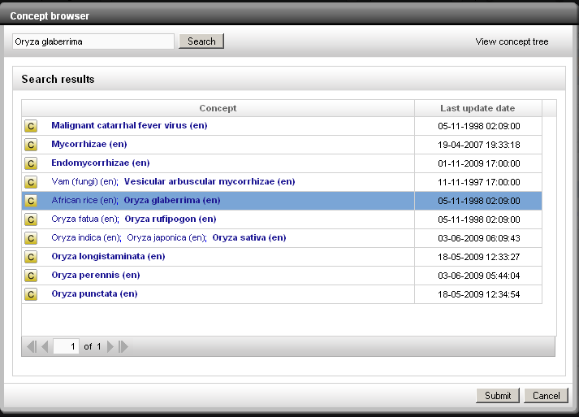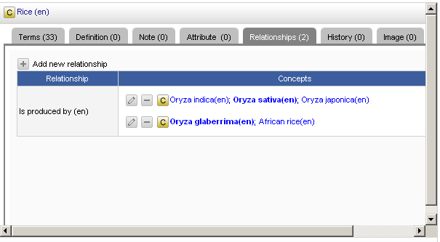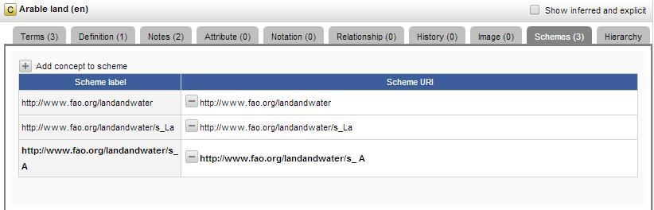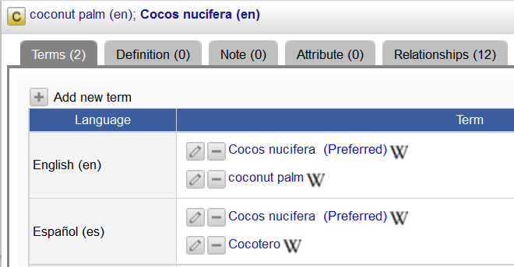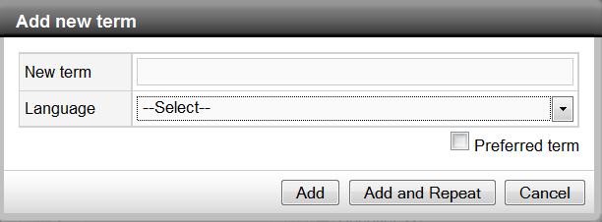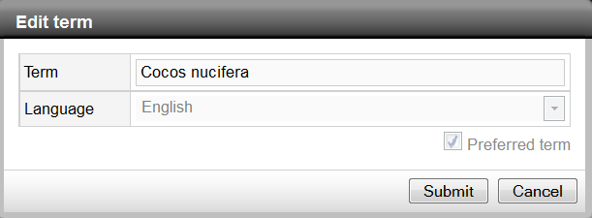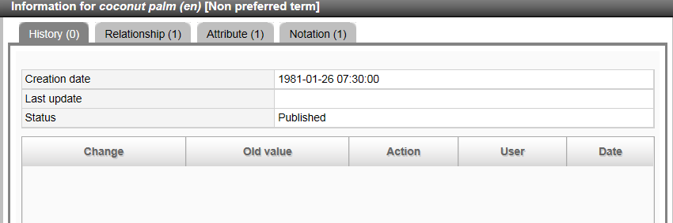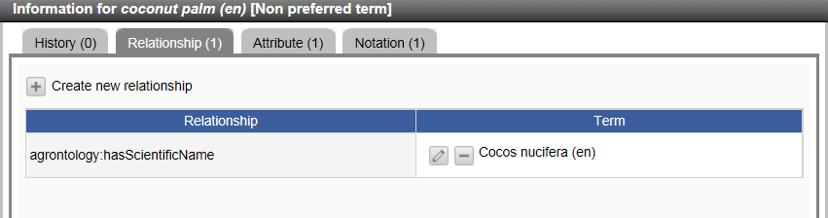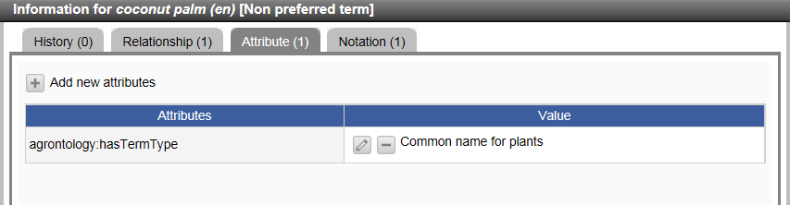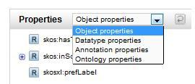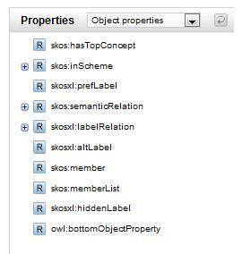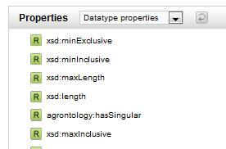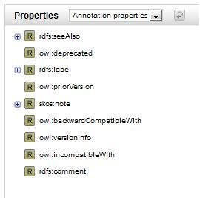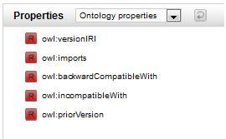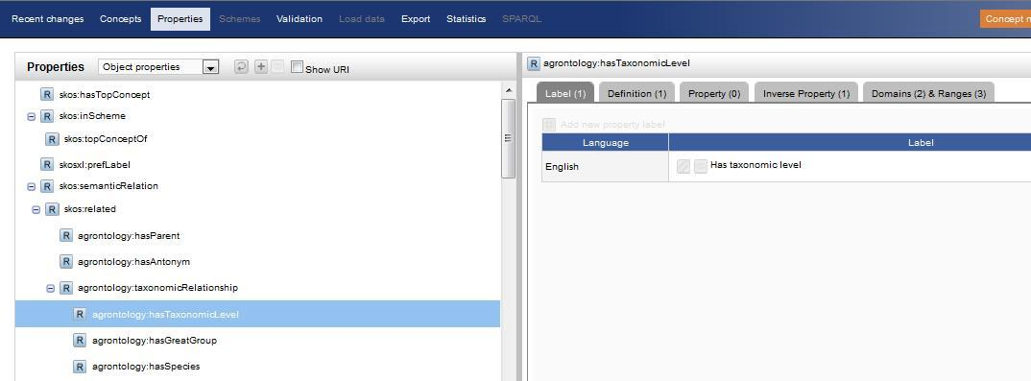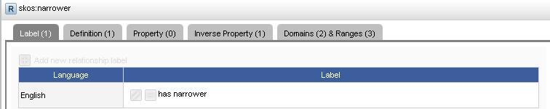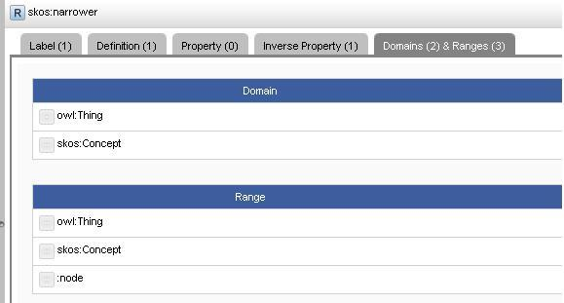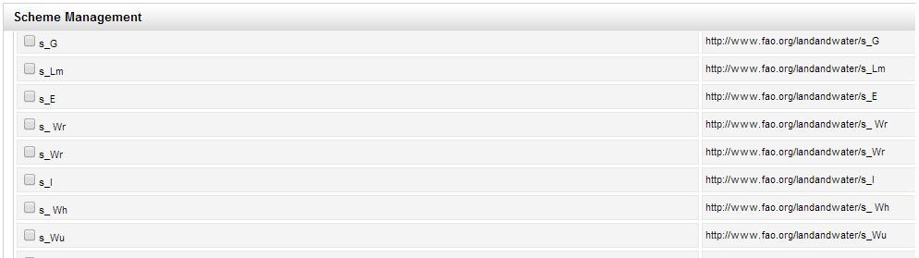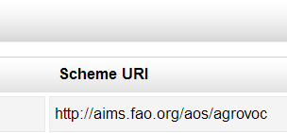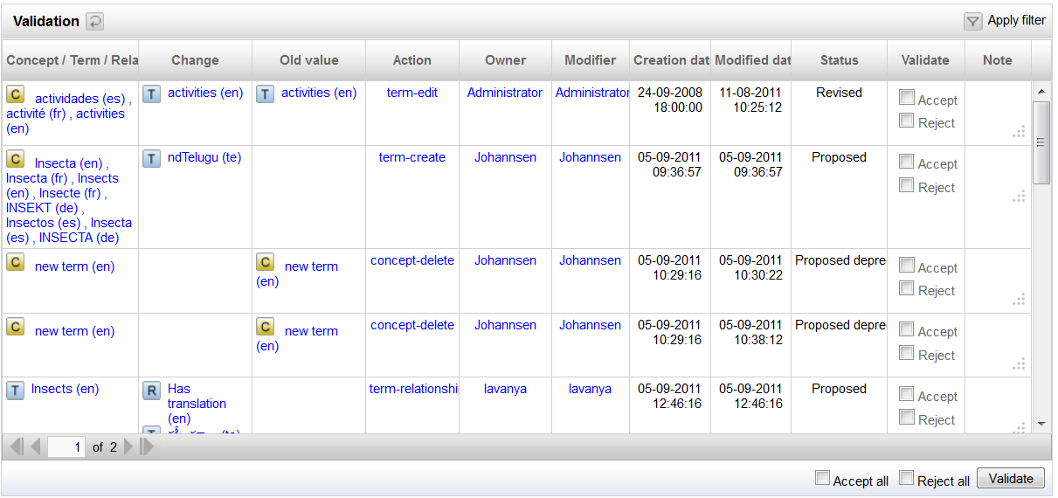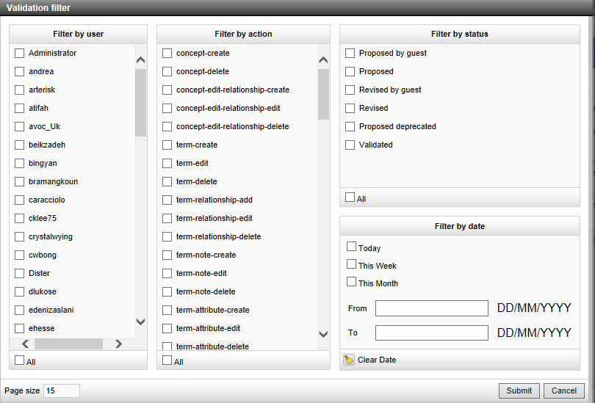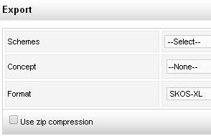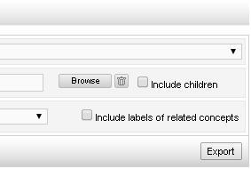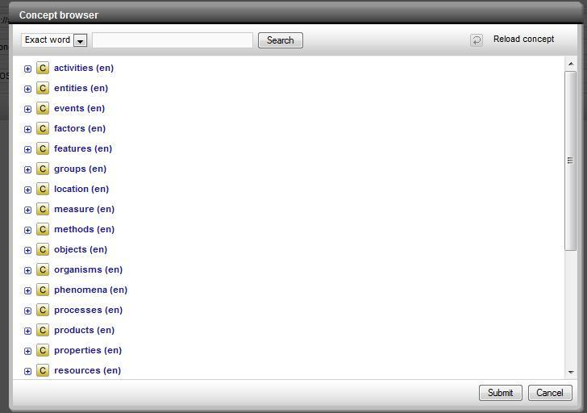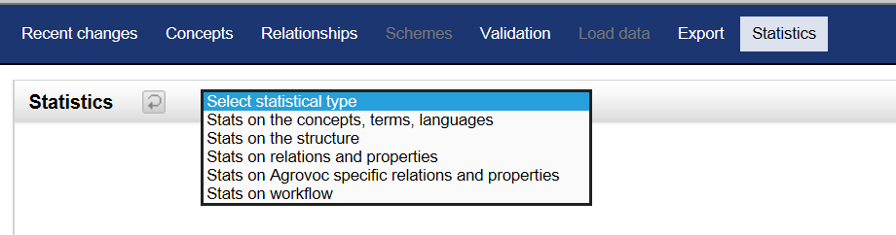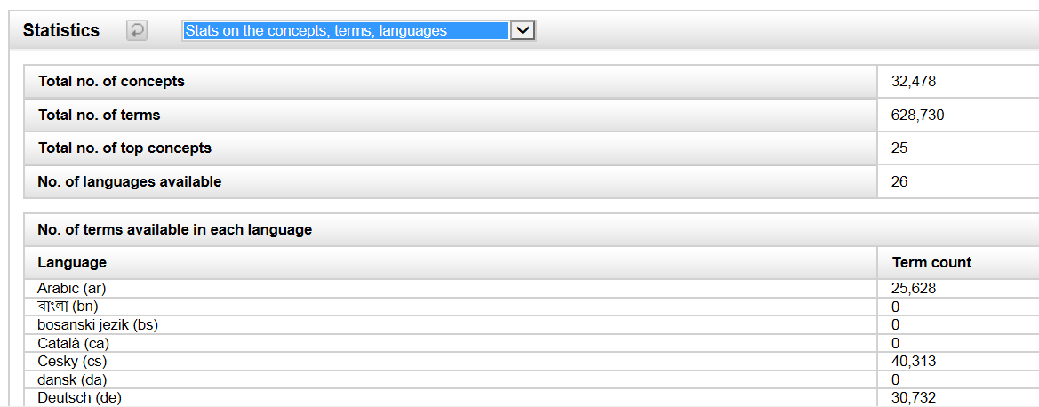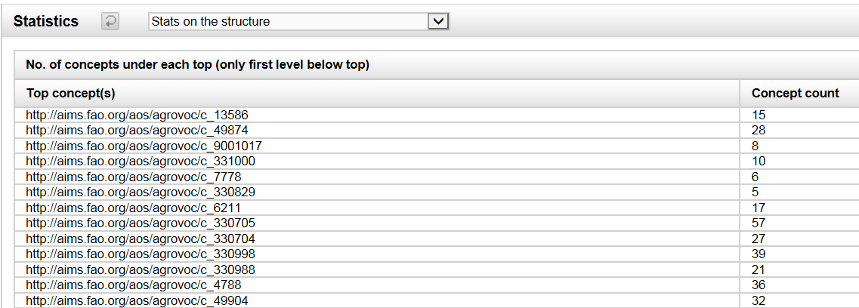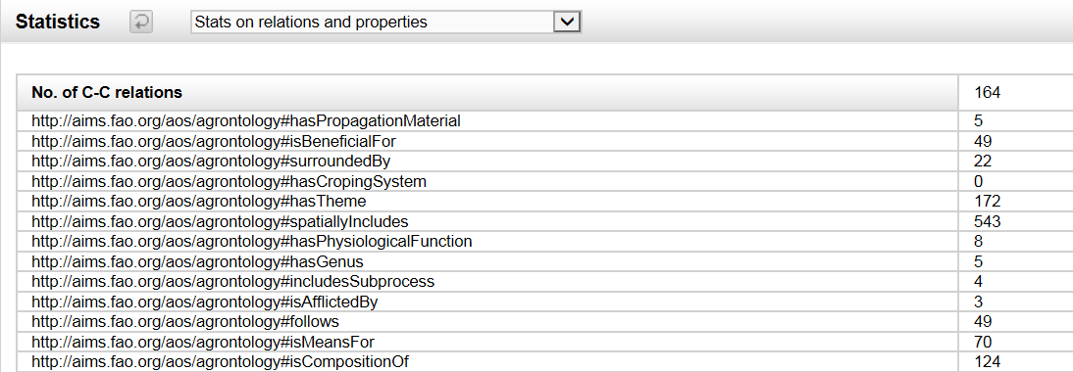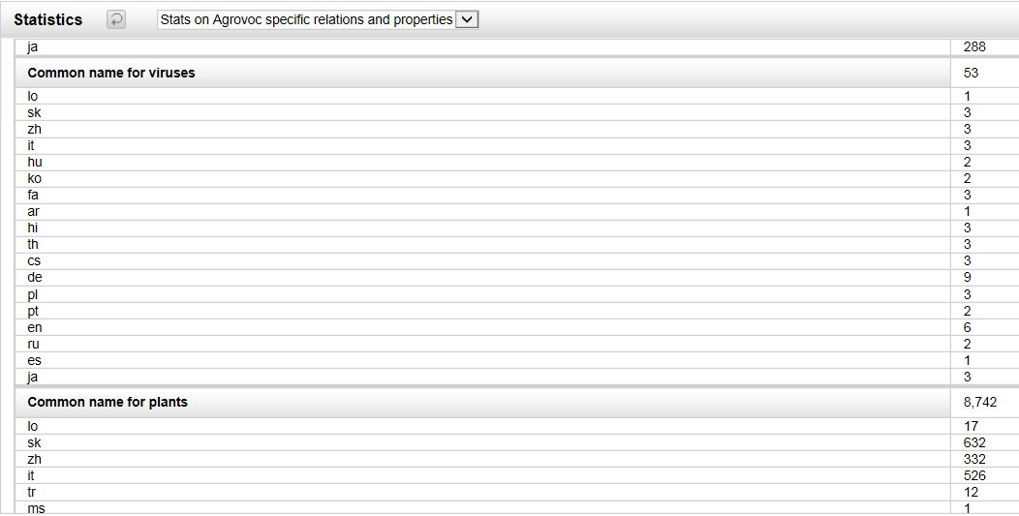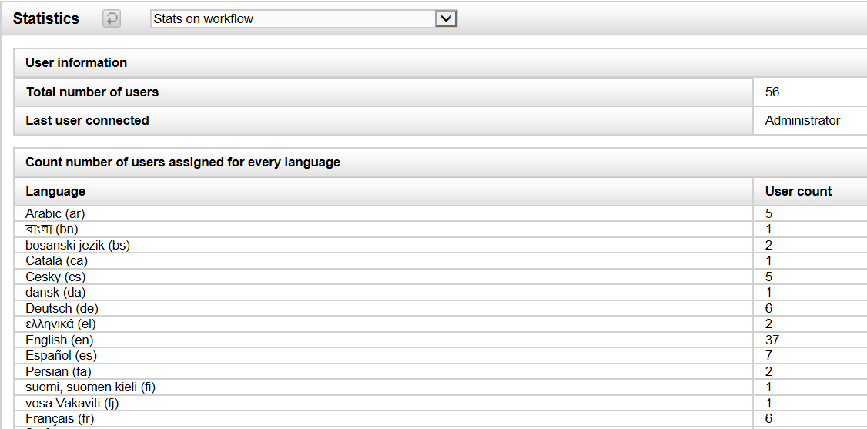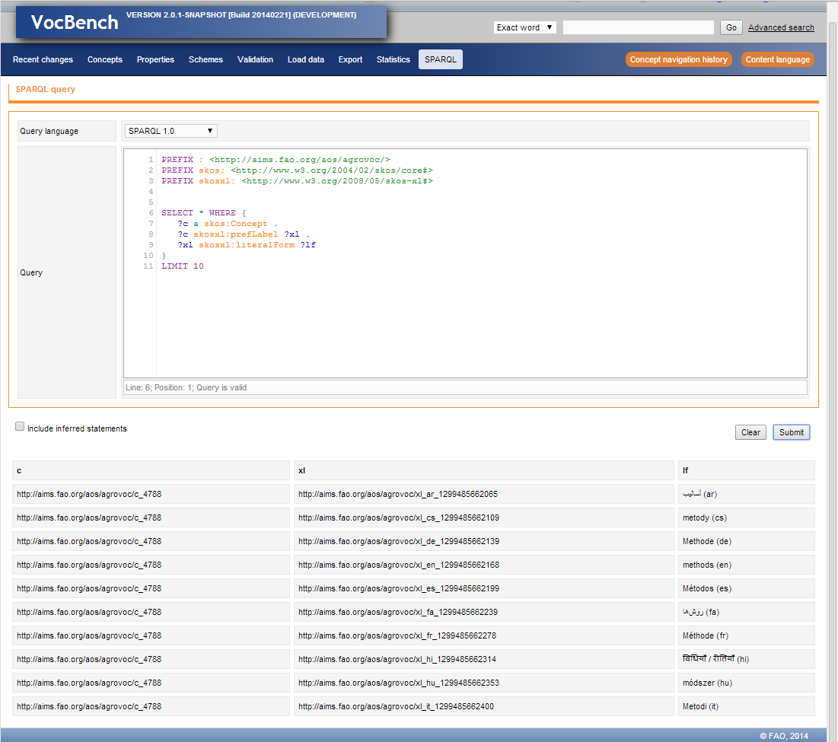

Useful Packages:

<http://tika.apache.org/> - Tika - OCR, java